# Voting Machine User Manual

In order to run the voting machine application, refer to the README file within the /etovucca folder. Once the voting machine is running, use the following guide for its use.

First, the user can access the homepage of the application by visiting [localhost:8000/cgi-bin/home.cgi](http://localhost:8000/cgi-bin/home.cgi)

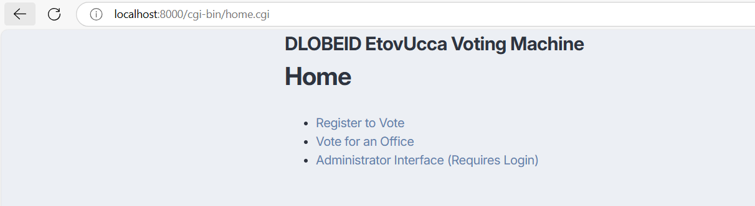

This gives the user a few different options. They can register to vote, cast a vote for an office, or login as an administrator to access the administrator interface.

## 1. Register to Vote

After clicking on “Register to Vote” the user will be brought to a form. In this form, the voter must enter their full legal name, county of residence, zip code of residence, and date of birth. The voter must be of legal age to vote (18).

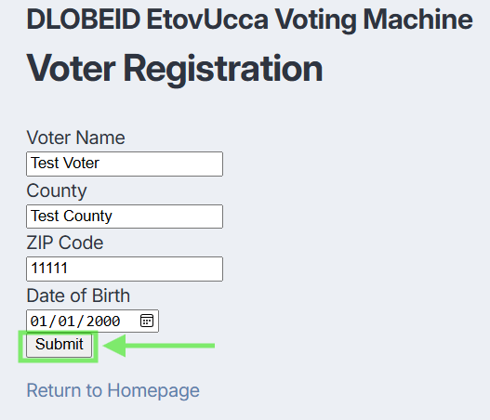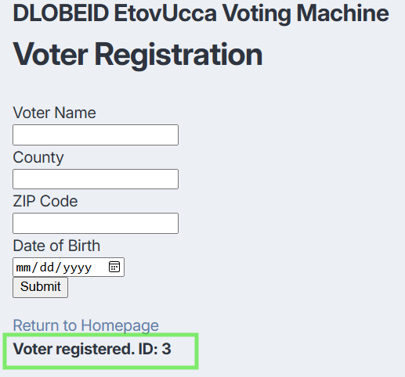

After registering, if the voter info is valid, you will receive a “Voter registered” message along with an ID. Remember this ID, you will need it in order to cast a vote.

## 2. Access the Admin Interface/Setup an Election

In order to open an election, register candidates, and see the results, you will need to access the admin interface. This can be done by clicking on “Administrator Interface (Requires Login)” from the application homepage. The password for the admin account is “admin”. After logging in, the user is able to access a variety of tools. They can view open elections, view closed elections, view published elections, add a new election, add an office to an existing election, correlate certain offices to only be accessible to voters ina certain zip code, add candidates to each office, and view the voting polls.

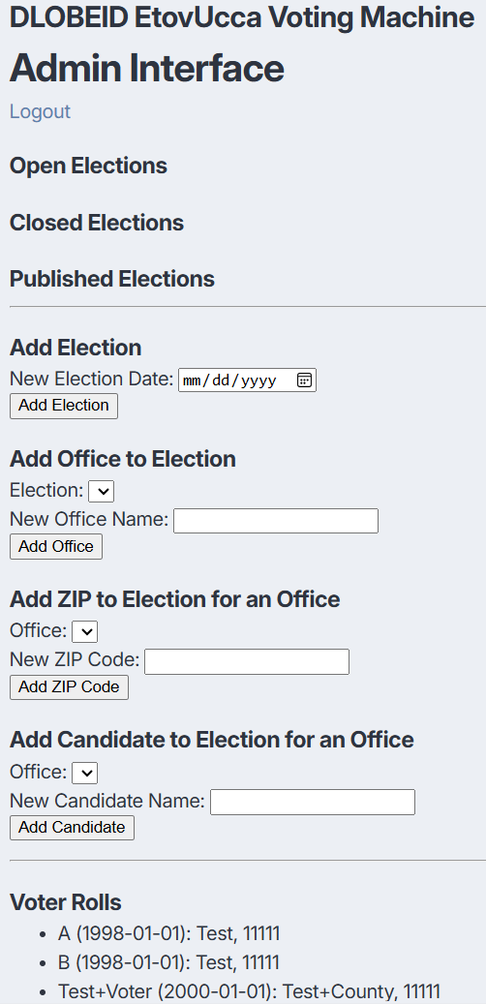

Here is an example of an election created. Clicking the “Open” button will allow voters to cast their ballots for this election.

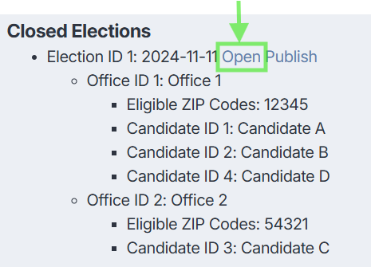

## 3. Cast a Vote

Then, each voter can navigate to the “Vote for an Office” page, which is linked on the homepage. From here, enter the voter ID that was given after registering. After this, each voter will have the option to select from the offices/candidates they are eligible to vote for based on their zip code. Choose the candidate you would like to vote for and select “Vote”.

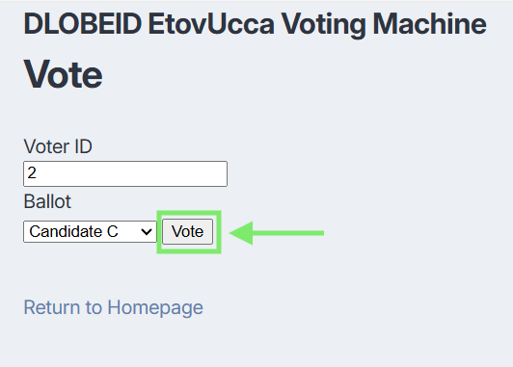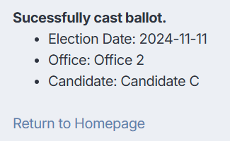

The voter will only be able to successfully cast a ballot if their zip code aligns with the zip code corresponding to each candidate. If not, they will receive a cast ballot error.